**《Fundamentals of Electric Circuits》homework CH.13**

**13.14 Obtain the Thevenin equivalent circuit for the circuit in Fig. 13.83 at terminals a-b.** (10’)

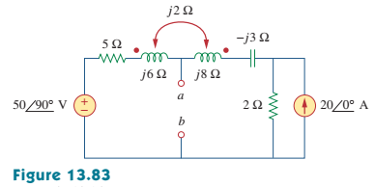

**13.25 For the network in Fig.13.94, find Zab and Io.** (10’)

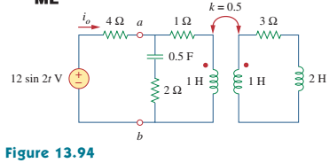

**13.28 In the circuit of Fig.13.97, find the value of X that will give maximum power transfer to the 20-Ω load.** (10’)

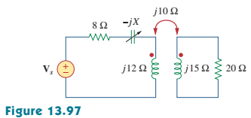

**13.29 In the circuit of Fig.13.98, find the value of the coupling coeficient *k* that will make the 10-Ω resistor dissipate 320 W. For this value of *k*, find the energy stored in the coupled coils at *t* = 1.5s.** (10’)

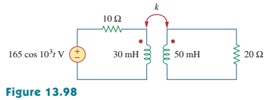

**13.30 (a) Find the input impedance of the circuit in Fig.13.99 using the concept of reflected impedance.**

**(b) Obtain the input impedance by replacing the linear transformer by its T quivalent.** (10’)

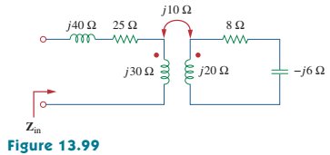

**13.35 Find currents I1, I2, and I3 in the circuit of Fig.13.104.** (10’)

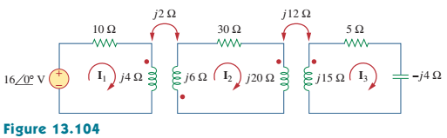

**13.46 (a) Find I1 and I2 in the circuit of Fig. 13.111 below.**

**(b) Switch the dot on one of the windings. Find I1 and I2 again.** (10’)

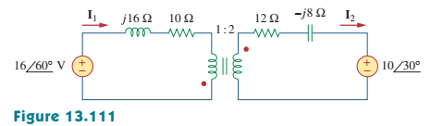

**13.54 A transformer is used to match an amplifier with an 8-Ω load as shown in Fig. 13.119. The Thevenin equivalent of the amplifer is: VTh = 10 V, ZTh = 128 Ω.**

**(a) Find the required turns ratio for maximum energy power transfer.**

**(b) Determine the primary and secondary currents.**

**(c) Calculate the primary and secondary voltages.** (10’)

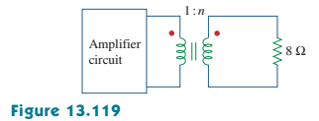

**13.63 Find the mesh currents in the circuit of Fig. 13.128.** (10’)

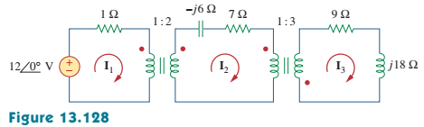

**13.65 Calculate the average power dissipated by the 20-Ω resistor in Fig. 13.130.** (10’)

